I need an upload component for Vue

Requirements: It needs to have full functionality as JIRA’s upload dialog as shown below:

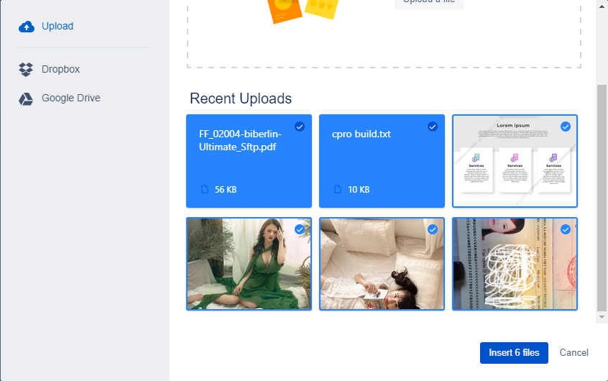

When no files are uploaded, it shows

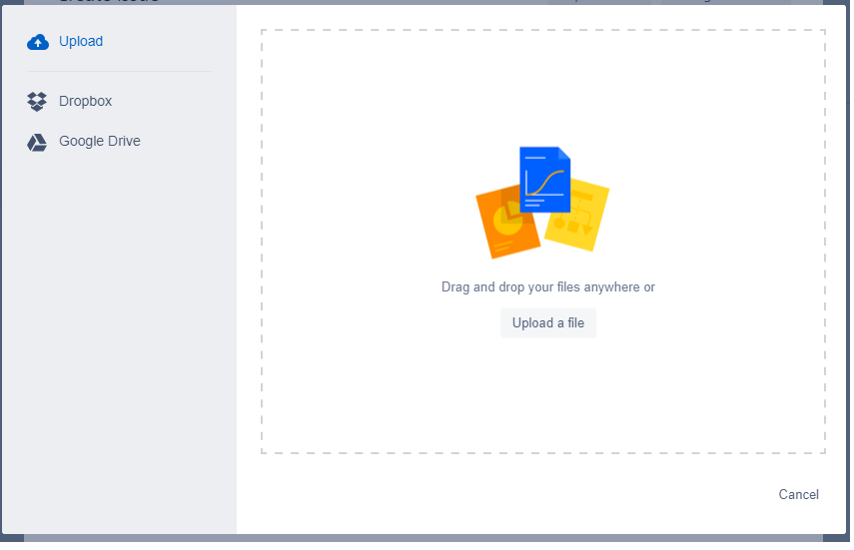

* It needs to show progress while uploading.
* It shows file size
* It shown thumbnail, selection like above
* When reopening the upload form, it shows the recently uploaded files. You can establish a simple test server to demonstrate that.
* It integrates with dropbox and Google drive